### **GOVERNMENT DEGREE COLLEGE, GUMMALAKSHMIPURAM**

**🌍 EVENT REPORT: WORLD AIDS DAY AWARENESS PROGRAMME**

**📅 Date:** 01-12-2024  
**📍 Venue:** Ewlenpeta  
**👥 Organised By:** NSS Unit I & II and Women Empowerment Cell  
**🎓 Lecturers Attended:** 10  
**🎓 Students Participated:** 200

**Objective of the Event:**

To observe **World AIDS Day** and spread awareness about **HIV/AIDS prevention, treatment, and stigma reduction**, the **Women Empowerment Cell** in collaboration with **NSS Unit – I & II** organized an impactful **Awareness Programme and Rally** on **1st December 2024** under the dynamic leadership of **Dr. T. Sreevaram, Principal**.

**Event Highlights:**

* The event began with a **mass awareness rally** at **Ewlenpeta**, where students and faculty marched with banners and slogans promoting safe practices and the importance of HIV/AIDS awareness.
* A series of student-led activities followed, including:
  + **Debate Competitions**
  + **Poster Presentations**
  + **Rangoli Displays**
  + **Reel-making on AIDS Awareness**
* These events not only showcased student creativity but also deepened their understanding of social responsibility and health consciousness.
* **Prizes were distributed** to students who excelled in these activities, encouraging active participation and team spirit.

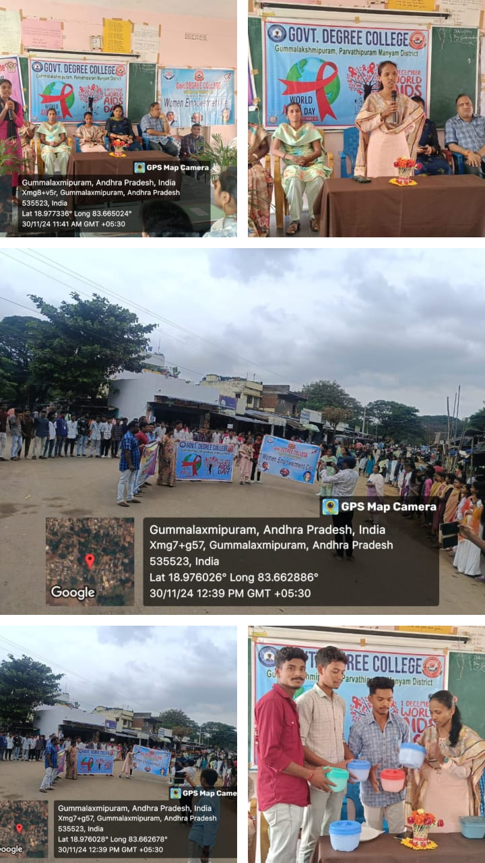

**Special Address by NSS Unit Coordinator:**

The NSS Unit Coordinator delivered a powerful and thought-provoking message:

“**Education is our strongest weapon in this fight.** We must spread awareness about safe practices, encourage regular testing, and ensure that those living with HIV/AIDS receive the care, respect, and support they deserve. Governments, health organizations, and communities must work together to improve access to treatment, eliminate discrimination, and ultimately aim for a world free of new HIV infections.”

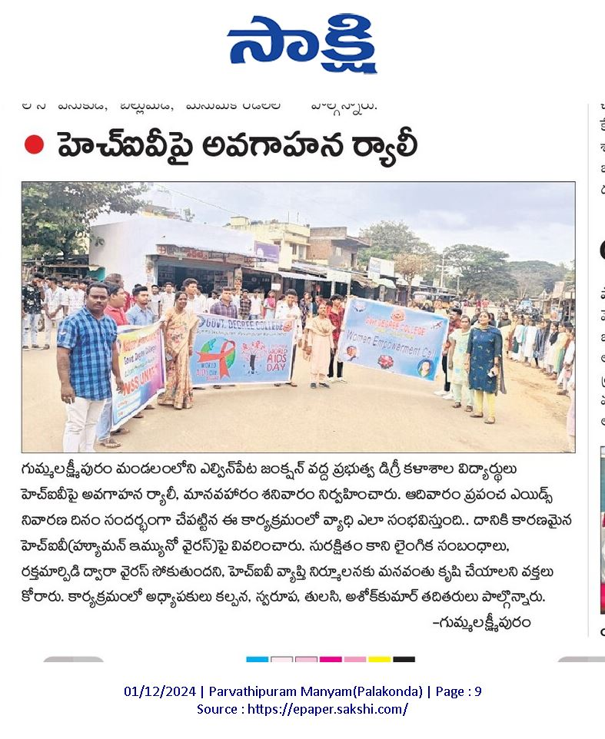

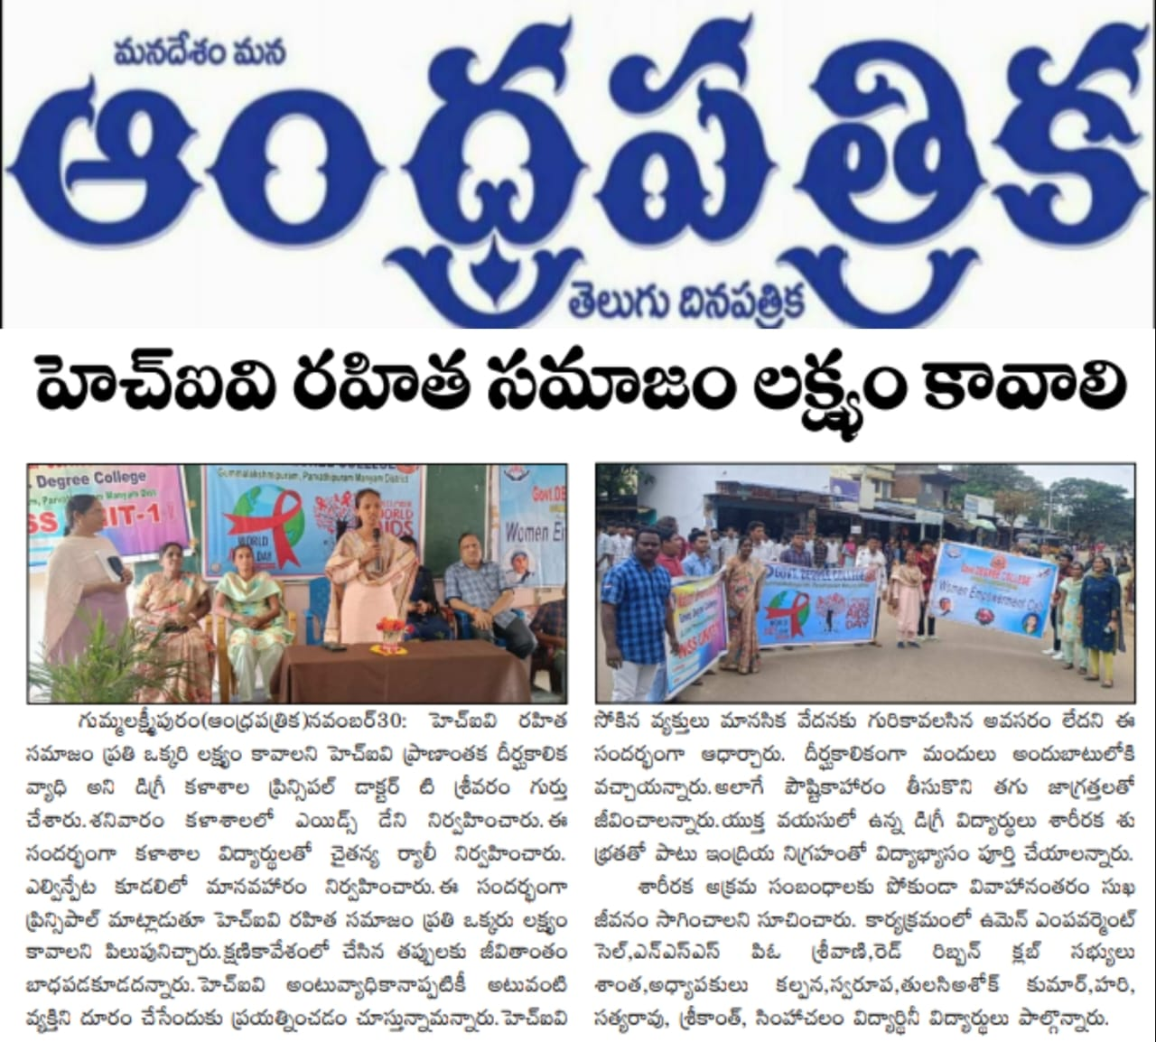

**Conclusion:**

The event was a **great success**, marked by the enthusiasm, creativity, and unity displayed by students and staff. It served as an eye-opener, helping participants reflect on their social responsibilities and empowering them to take forward the message of **health, dignity, and equality for all**. The program truly embodied the spirit of **awareness, education, and collective action**.

Top of Form

Bottom of Form